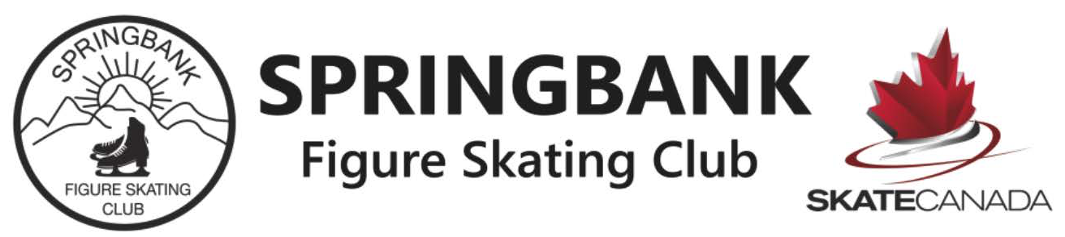
Summer time is here, we all enjoy the long warm days! It is time to look back, look at these pictures of all smiling faces, friendships between skaters and coaches. Coaches, skaters, parents we all strive to be a welcoming, open club, where skaters can achieve their highest figure skating goals, and make lifelong friendships.
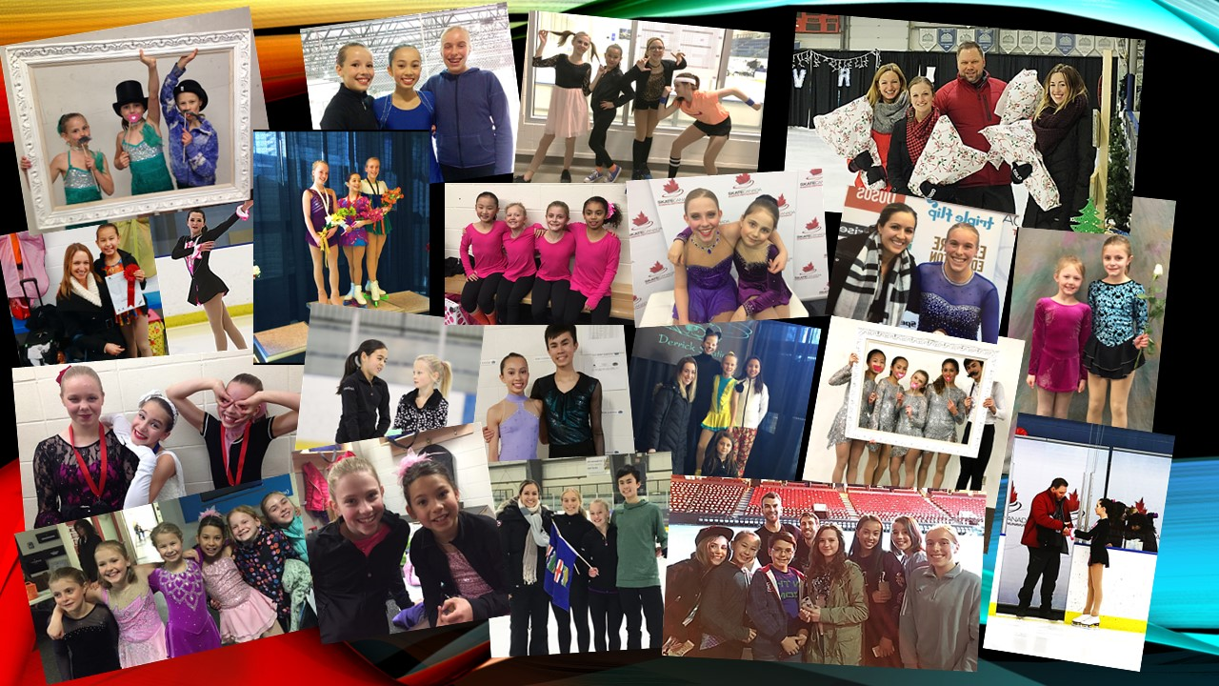
SFSC experienced a lot of firsts this season. The new President Karla Dolaptchiev showed excellent leadership, with Vice President Carol-Ann Titus they presented dedication and countless hours of volunteer work. Kailee Myhill our Program Director provided much needed technical help with every-day-operational manners, as well as improvement of the STARskate and Competitive program. Kate Macdonald executed the re-designed CANskate program with huge success.
New positions may be formed, roles change but what stays constant at SFSC is the support we can rely on, board members, parent volunteers, program assistants dedicate endless hours to help. Music playing, social events, and fundraising would not have been possible to make this club the one we are all so proud of.
Since our latest newsletter, our skaters very successfully competed at the Chinook Open, in Lethbridge, as well as at the 2017 United Cycle Sunsational in Edmonton. Once again Lots of podium finishes, and personal bests were achieved.
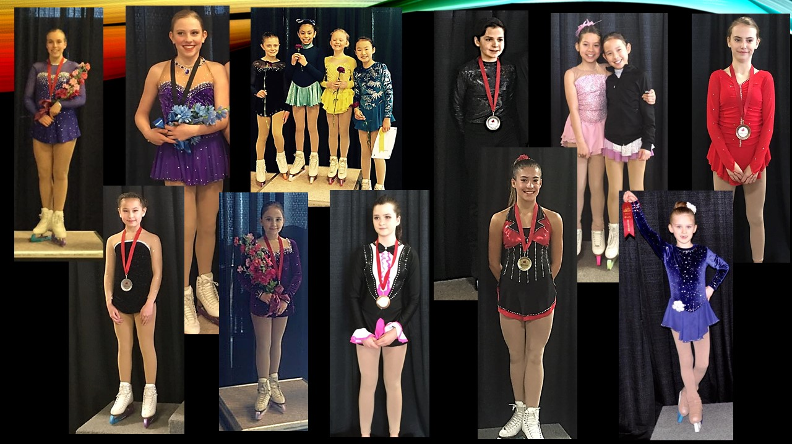
Two of our club members received special recognition at the Skate Canada Alberta Section this April. Benjamin for his Gold medals at the Special Olympics World Championship and Dawson for his Gold at Skate Canada Challenge and Silver at Skate Canada Nationals. Dawson was also awarded the Toller Cranston award. This memorial fund athlete award celebrates one of figure skating’s greatest artists. It was created to distinguish young skaters who display exceptional artistry on ice at the Canadian Tire National Skating Championships in the novice and junior categories. Way to go, Benjamin and Dawson, we are so proud of you!
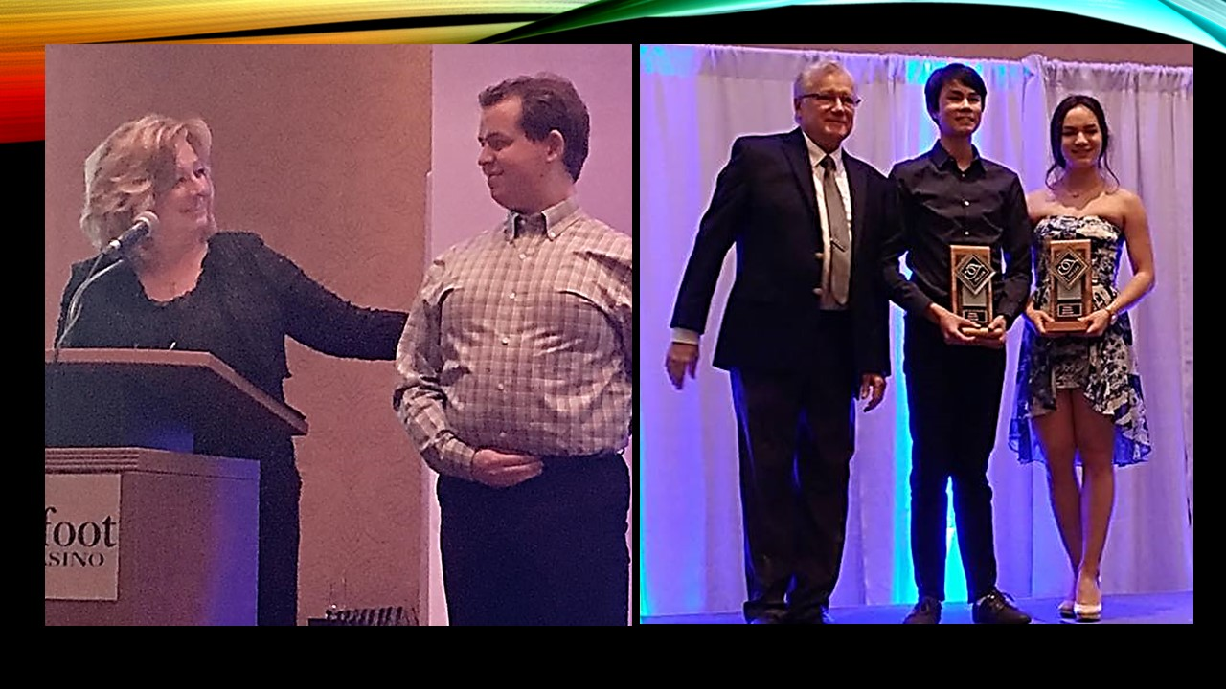
We are very excited and proud to announce that one of our head coaches Natasha Taylor has been accepted into the Skate Canada high-performance mentorship training program. This is one of the highest accomplishments a coach in Canada can achieve and shows that Skate Canada recognised her talent and potential with which she will be able to represent Canada internationally. As I am writing this letter, Natasha is competing at the 2017 ISU Adult Competition in Oberstdorf, Germany, good luck and can’t wait to write about your success.
Upcoming events
We will all get together to celebrate the End of the Season at our Year-End-Banquet on June 2, 2017, at the Pinebrook Golf Course in Springbank.
Please stay in touch over the summer to hear about fall registration information and other news, so please keep visiting our Website springbankskating@gmail.com regularly!

Questions?
As always you can contact Kailee Myhill our Technical Director with any questions regarding STAR skate and Competitive skating at springbankskating@gmail.com 403-616-7909

For CanSkate Spring Registration visit our website, or contact Kate MacDonald at s.katemacdonald@gmail.com
Please also visit our website at www.springbankskating.com or on Facebook at Springbank Figure Skating Club.

A happy, healthy and sunny summer to everyone!

Contributed by Eniko Kapocsi-Kiss

